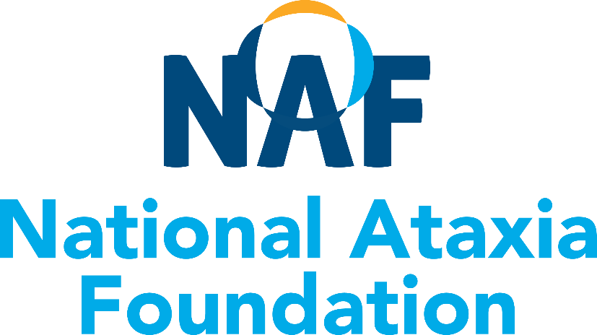

Neurologist Resource List
Canada
Includes Neurologists and Ataxia Clinics

Disclaimer:
This is a resource list of neurologists who have expressed an interest in seeing patients with Ataxia. It is offered as a service to the ataxia community by the National Ataxia Foundation (NAF). However, NAF does not verify the medical qualifications, practice capabilities or licenses of these neurologists and NAF is not liable for any diagnosis or medical treatments given by the medical professionals contained on this resource list. If you have questions or concerns, please contact the National Ataxia Foundation at 763-553-0020 or naf@ataxia.org. 12-19.2022

ALBERTA

Oksana Suchowersky, MD, FRCPC, FCCMG  Professor of Medicine,  Medical Genetics, and Pediatrics,  Toupin Research Chair in Neurology  Director, Clinical Genetics,  University of Alberta  7-112Q Clinical Sciences Building  11350 83 Ave  Edmonton‎ AB ‎ T6G 2G3  CANADA  Phone: (780) 248-5418  Fax: (780) 248-1807  Alicia Chan, MD  University of Alberta Hospital  Department of Medical Genetics  8-53 MSB 8440 112 St NW  Edmonton, AB T6G 2H7  CANADA  Phone: (780) 407-8314  Sees pediatric patients  Jean K. Mah, MD, MSc  Division of Pediatric Neurology  Alberta Children's Hospital  28 Oki Dr NW  Calgary AB T3B 6A8  CANADA  Phone: (403) 955-7609 –  Fax: (403) 955-2922  Shannon Searle  (neuromuscular clinic nurse)  Sees pediatric patients | Beste Edguer, MD  204-11010 101 Street NW  Edmonton AB T5H 4B9  CANADA  Phone: (780) 441-9880‎  Fax: (780) 441-9890‎  Sees adult patients  Scott Kraft, MD  University of Calgary  Calgary Movement Disorders Clinic  2500 University Drive NW  Calgary, AB T2N 1N4  CANADA  Phone: (403) 944-4364  Gerald Pfeffer MD PhD  Clinical Neurosciences and Medical Genetics, University of Calgary  Neuromuscular Clinic, South Health Campus  5th floor Module D  4448 Front Street SE  Calgary, AB, T3M 1M4  Tel 403-956-3535  Fax 403-956-3494
BRITISH COLUMBIA

Dr. Blair R. Leavitt  UBC Neurogenetics Clinic  University of British Columbia  Rm S179, UBC Hospital  2211 Westbrook Mall  Vancouver BC V6T 2B5  CANADA  Phone: (604) 822-7739  Fax: (604) 822-7970 | Dr. Katherine Selby, Pediatric Specialist  Neuromuscular Clinic  BC Children's Hospital  4480 Oak Street,  Vancouver BC V6H 3V4  CANADA  Phone: (604) 875-2345 local 7964  Fax: (604) 875-2285

NEW BRUNSWICK

Colleen O'Connell, MD  Research Chief  Stan Cassidy Centre for Rehabilitation  Fredericton NB E3B 0C7  CANADA  Phone: (506) 447-4294  Fax: (506) 447-4749  Sees both adult & pediatric patients  Wendy A. Stewart, MD  54B Marr Road  Rothesay, NB E2E 3K7  CANADA  Phone: (506) 848-4622  Fax: (506) 848-4659  Sees pediatric patients | Kyna Squarey, MD  106A-1600 Main Street  Moncton, NB E1E 1G5  CANADA  Phone: (506) 857-5198  Fax: (506) 857-5702  Sees adult patients

NOVA SCOTIA

Joseph Dooley, MB BCh  IWK Health Centre  Pediatric Neurology Division  5850/5980 University Ave  Halifax NS B3K 6R8  CANADA  Phone: (902) 470-8488  Fax: (902) 470-8486  See pediatrics patients | Ian Grant, MD  QEII HSC – HI Site, Neurology Department  1796 Summer St  Halifax NS B3H 3A7  CANADA  Phone: (902) 473-3731  Fax: (902) 473-4438  Sees adult patients
ONTARIO

Christine Ghadery, MD  Heart and Health Clinic  Movement Disorder Center  204-565 Sanatorium Road  Hamilton, ON, L9C 7N4  Phone: 2897609594  Fax: 9052963858  www.heartandhealth.ca | Jane Liao, MD  Scarborough Health Network  3030 Lawrence Ave E #206, Scarborough, ON M1P 2T7, Canada  Phone: 416-289-0185  Fax: 416-289-0187  Sees adult patients  Renato Munhoz, MD  Elizabeth Slow, MD, PhD  Toronto Western Hospital  Movement Disorder Clinic  399 Bathurst Street  7MC-410; 399 Bathurst Street  Toronto, ON  M5T 2S8  CANADA  Phone: (416) 603-6422  Fax: (416) 603-5004  Sees adult patients  Michel Melanson, MD  Kingston General Hospital  Connell 7  76 Stuart Street  Kingston ON K7L 2V7  CANADA  Phone: (613) 549-6666 Ext. 3250  Sees patients of all ages.  Teesta Soman, MD  Pediatric Movement Disorders Program  The Hospital for Sick Children  555 University Avenue  Toronto ON M5G 1X8  CANADA  Phone: (416) 813-5668  Fax: (416) 813-6334  Sees pediatric patients  David Grimes, MD  The Ottawa Hospital –  Civic Campus  Division of Neurology – C2  1053 Carling Avenue  Ottawa ON K1Y 4E9  CANADA  Phone: (613) 798-5555 ext. 18162  Sees adult patients
  Craig Campbell, MD
  Children's Hospital of Western Ontario
  800 Commissioners Road East
  London ON N6A 4G5
  CANADA
  Phone: (519) 685-8332
  Fax: (519) 685-8350
  Sees pediatric patients
  Hugh McMillan, MD
  Children's Hospital of Eastern Ontario
  401 Smyth Road,
  Ottawa, ON K1H 8L1
  CANADA
  Phone: (613) 737-7600
  Sees pediatric patients
  Dr. Mark Tarnopolsky
  Neuromuscular Disease Clinic
  Hamilton Health Services-McMaster Division 2H
  1200 Main Street West
  Hamilton ON L8N 3Z5
  CANADA
  Phone: (905) 521-7933
  Fax: (905) 521-2638
  From the underground parking, take the Red elevators to Level 2, then turn left. We are the first clinic on the right. Patients are seen on Mondays and Tuesdays. Referrals from a physician should be faxed.
  University Hospital
  London Movement Disorders Centre (LMDC)
  Dr Mandar Jog
  339 Windermere Rd,
  London, ON , N6A5A5
  Phone: 519-663-3814
  Fax: 519-663-3174
QUEBEC

Bernard Brais M.D.C.M., M.Phil., Ph.D., FRCP(C)  Neurogeneticist  Professor, Departments of Neurology and Neurosurgery and Human Genetics  Co-director of the Rare Neurological Diseases Group  Faculty of Medicine, McGill University  Montreal Neurological Institute  Room 622B  3801, University Street  Montreal QC H3A 2B4  CANADA  Phone: 1 (514) 398-3334;  (Catherine Boyer)  Fax: 1 (514) 398-4340  Sees adult patients  Centre hospitalier de l’Université de Montréal (CHUM)  NAF Ataxia Center of Excellence  Antoine Duquette, MD, MSc, FRCP(C)  CRCHUM  900 rue Saint-Denis  Montreal QC H2X 3H8  CANADA  Phone: (514) 890-8123  Fax: (514) 412-7139  Sees adult patients  Marie-France Rioux, MD  CHUS - Hôpital Fleurimont  3001 12e Avenue Nord  Sherbrooke QC J1H 5N4  CANADA  Phone: (819) 346-1110  Sees both adult & pediatric patients | Massimo Pandolfo, MD  Clinical Professor  Department of Neurology and Neurosurgery, McGill University  Co-Director, Clinical Research Unit (CRU)  The Neuro (Montreal Neurological Institute/Hospital)  3801, University Street  Montreal, QC, H3A 2B4  Canada  Phone: +1 (514) 398-5034  (Pasqua Amato)  Fax :+1 (514) 398-2745  Renée-Myriam Boucher, MD  CHUL-Centre Mère-Enfant  2705 boul Laurier  Québec QC G1V 4G2  CANADA  Phone: (418) 654-2708  Sees pediatric patients  Anne-Louise Lafontaine, MD  Montreal General Hospital  L7-312-1650 Cedar Ave.  Montreal, QC H3G 1A4  CANADA  Phone: (514) 934-8026  Sees adult patients

